IBM Data Science Professional Certificate

Capstone Project

Experiential Adoption

Increasing Animal Adoption thru Pet Cafes

In Northern Germany

Maria Victoria Ochave

23 September 2020

Experiential Adoption:

Increasing Animal Adoption thru Pet Cafes in Northern Germany

1. Introduction

Animal Cafés, also known as Pet Cafés have been very popular since it was first established in Taiwan in 1998 was primarily for people who wanted to spend time with animals and at the same time enjoy some drinks and food[[1]](https://en.wikipedia.org/wiki/Animal_cafe). Although more of these Cafés were built worldwide, they are still more popular in Asia. In recent years, a number of these cafes have started partnering up with local shelters to help rescued pets to be adopted. In the Philippines, a Non-government organization called PAWS partnered up with one of the biggest mall chains and opened up a cafe in an attempt to raise awareness on animal welfare[[2]](https://news.abs-cbn.com/life/08/17/19/get-up-close-and-personal-with-shelter-animals-at-this-pet-caf-for-a-cause).

Shelters and rescuers are always looking for new ways for homeless pets to interact with potential adoptive families. They have worked to create open and inviting areas where people can have one-on-one time with pets before deciding to adopt, working to change the stereotypes about shelter pets. Getting consumers involved, particularly with social causes, can be challenging, prompting organizations to turn to experiential marketing tactics.

Experiential marketing is a marketing technique that creates experiences between brands and consumers. Experiential campaigns use an activation (e.g., product sampling, immersive experiences, stunts, events, etc.) to bring brands to life and interact directly with the target audience. One such campaign is called experiential adoption[[3]](https://www.trendhunter.com/protrends/experiential-adoption), whereby people can experience interacting with pets without actual ownership. In this process, potential adoptive persons have a chance to decide thoroughly which pet they would adopt or if they or their family is ready to have a pet at home

In Germany, a country with some of the most progressive animal welfare laws and attitudes, there are private animal shelters called “Tierheim”, which take care of homeless animals. Tierheim literally means animal *(‘tier’)* house *(‘house’)*. The shelter takes in a wide variety of animals, including exotic ones. Approximately 15000 animals are taken in annually, 40% of which are stray. The criteria for adoption are strict, for example; they don’t allow adoption where the house is empty for more than 8 hours/day[[4]](https://worldanimalrescuefund.org/2017/03/90-adoption-rate-at-german-animal-shelters/#:~:text=Though%20Tierheim%20shelter%20over%2010%2C000,rate%20goes%20far%20beyond%2090%25.).

Germany itself only has a few Pet Cafe's but it's because most restaurants, hotels and public transport are pet-friendly. However, these establishments, though pet-friendly, does not necessarily advertise the importance of pet adoption.

1. Animal Café (<https://en.wikipedia.org/wiki/Animal_cafe>)
2. Pet Café for a cause (<https://news.abs-cbn.com/life/08/17/19/get-up-close-and-personal-with-shelter-animals-at-this-pet-caf-for-a-cause>)
3. Experiential Adoption(<https://www.trendhunter.com/protrends/experiential-adoption>)
4. Adoption rate at German Shelters(<https://worldanimalrescuefund.org/2017/03/90-adoption-rate-at-german-animal-shelters/#:~:text=Though%20Tierheim%20shelter%20over%2010%2C000,rate%20goes%20far%20beyond%2090%25.>)

Experiential Adoption:

Increasing Animal Adoption thru Pet Cafes in Northern Germany

1.1 Business Problem

This project will aim to find an optimal location to establish Pet Cafes in **North Germany**. This report targets entrepreneurs or NGO's interested in opening a business with a social cause, specifically in Animal welfare.

Since Germany, in general, has an ever-increasing number of pet-friendly restaurants and establishments, we will try to find locations that are nearby Animal Shelters hence making it possible for shelters to showcase their animals in the Cafes. The main goal is to help Animal Shelters in promoting animal adoption and fostering. We will particularly target shelters in districts where there is a bigger population and with a better accessibility in terms of public transport.

A ranking of optimal venues will be done which will give us a better suggestion where to establish Cafes.

1.2 Introduction to North Germany

 North Germany[[1]](https://en.wikipedia.org/wiki/Northern_Germany) is the region in the northern part of Germany, whose exact area is not precisely or consistently defined. It varies depending on whether one has a linguistic, geographic, socio-cultural or historic standpoint. The following five coastal states are regularly referred to as Northern Germany

* Schleswig-Holstein,
* Mecklenburg-Vorpommern,
* Lower Saxony (Niedersachsen)
* city-states Hamburg and Bremen

Though geographically in the northern half of Germany, North Rhine-Westphalia, Brandenburg, and the northern parts of Saxony-Anhalt are rarely referred to as Northern Germany and instead are almost always associated with Western Germany and the historical East Germany respectively. During the second half of the 20th century, a cultural division of northern Germany into an Eastern and a Western part has become more pronounced due to the 1949–1990 division of all of Germany into West Germany and East Germany, where identities based upon the former Iron Curtain and mutual prejudices regarding what once was the other side may persist today.

1. Northern Germany (<https://en.wikipedia.org/wiki/Northern_Germany>)

Experiential Adoption:

Increasing Animal Adoption thru Pet Cafes in Northern Germany

1. DATA
   1. Data Source

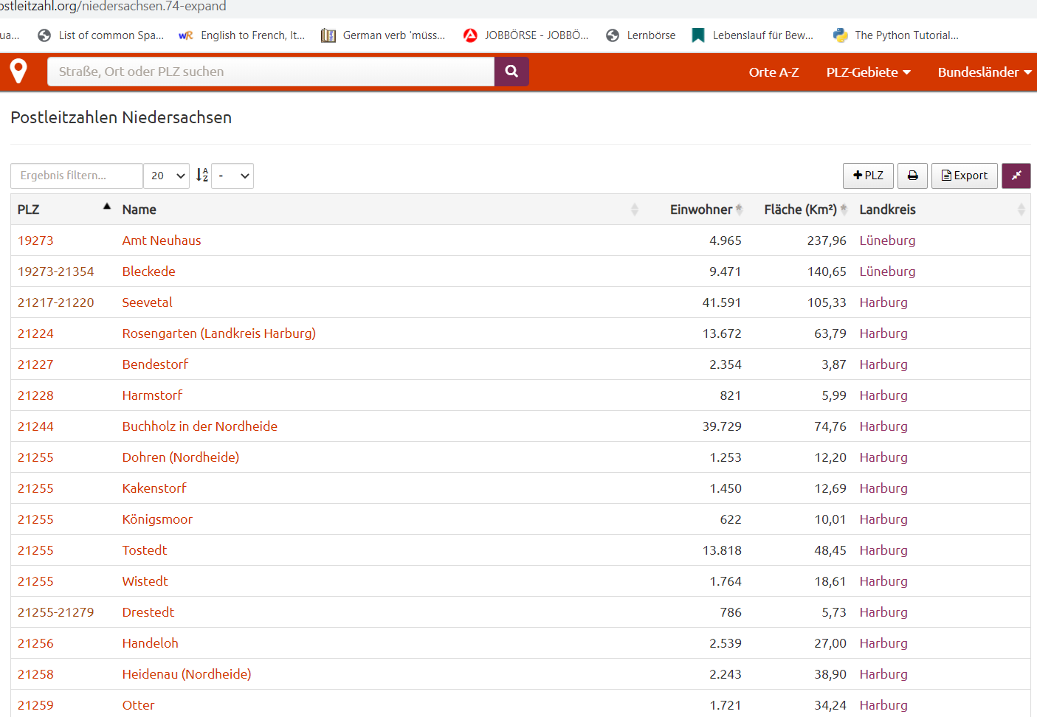A list of postal regions and codes can be found in *suche-postleitzahl.org. The* list in *suche-postleitzahl* gives a more detailed list of all the neighborhoods and their corresponding postal codes and population. The data can be downloaded as jpeg, csv, or excel hence this site came in very handy.

**Table 1: Raw data from suche-postleitzahl**

For the data frame, I used data from 'suche postleitzahl' website and dropped the Land Area *(“Flache”),* and unnamed columns, leaving only the columns for “*Landkreis”,* Population*(“Einwohner”)*, States, and Postal Code(PLZ). *Landkreis* is the same as a District. I merged all the data from all the 3 focus states into one data-frame. I did not include name of neighborhoods as the Landkreis is more accurate for location.

The geospatial coordinates were gathered thru OpenDataSoft(ODS)[4] website. ODS listed coordinates together with the postal codes for better accuracy.

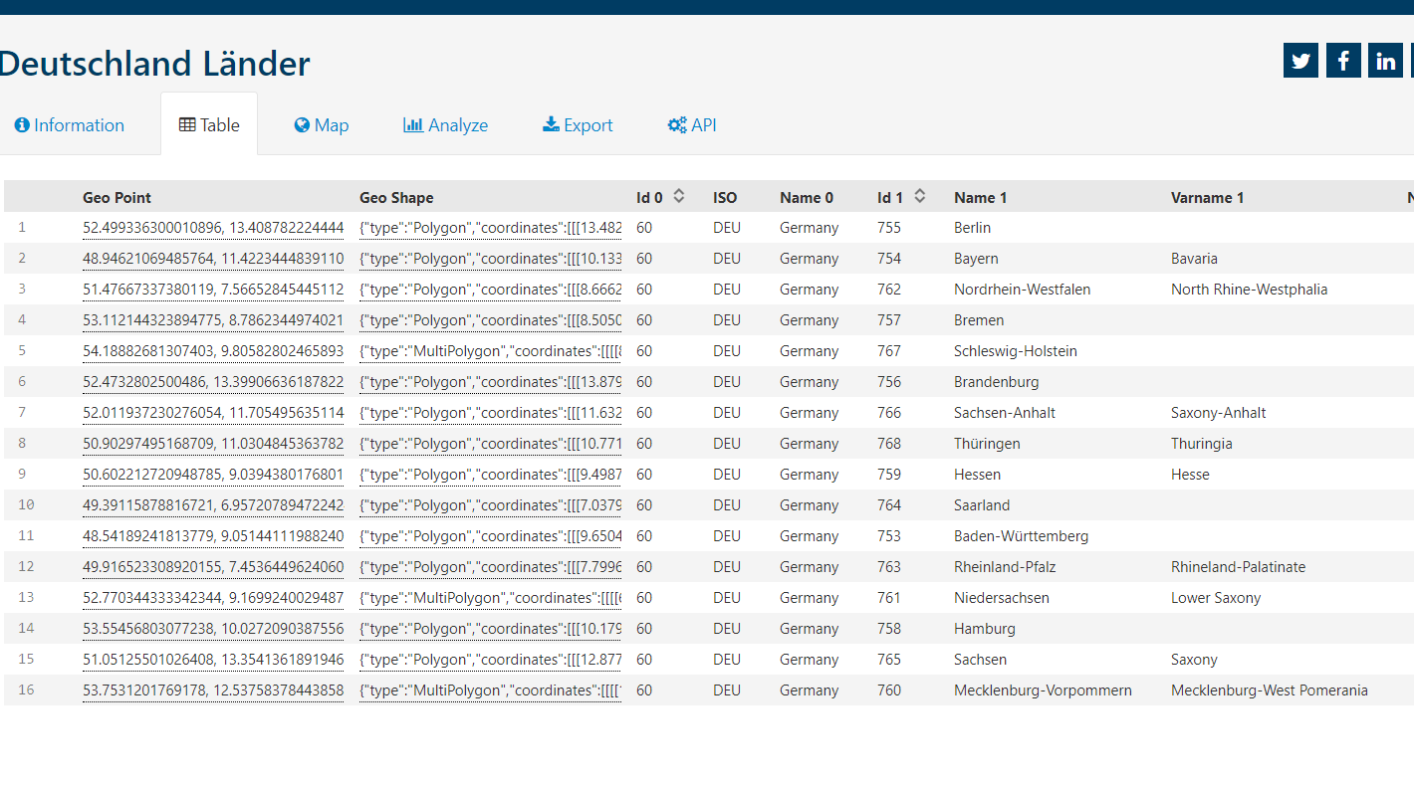

**Table 2: Raw data from ODS website**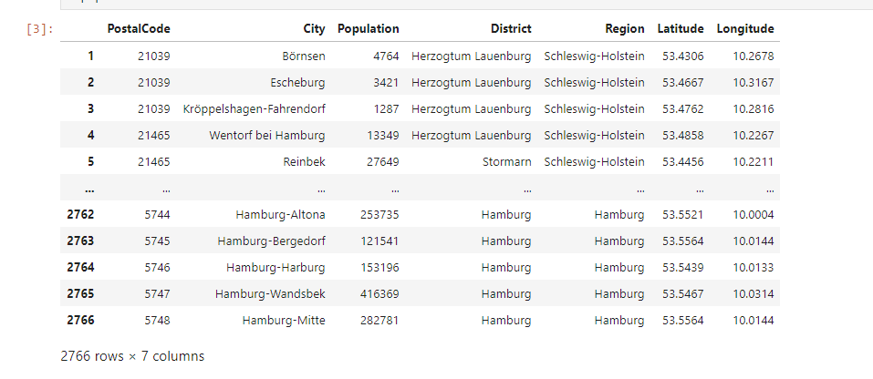

**Table 3: Merged data from both datasets**

Experiential Adoption:

Increasing Animal Adoption thru Pet Cafes in Northern Germany

The data described above will be used to find the animal shelters located in each neighborhood from the targeted states and assess their accessibility. Foursquare API and Folium map is used for visualization.

1. Methodology
   1. 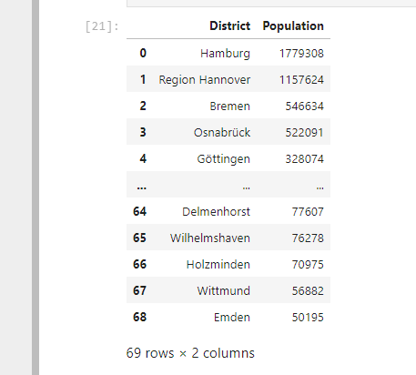Data Analysis

Based on the data we have, we can already infer which districts we can focus on evidenced by its population. The top 10 Districts with a big population density are as follows:

* Hamburg
* Hannover (Niedersachsen)
* Bremen
* Osnabrück (Niedersachsen)
* Göttingen (Niedersachsen)
* Emsland (Niedersachsen)
* Oldenburg (Niedersachsen)
* Pinneberg (Schleswig-Holstein)
* Rendsburg-Eckernförde (Schleswig-Holstein)
* Hildesheim (Niedersachsen)

As you can notice, most of the populated District are in Lower Saxony (Niedersachsen) and the top 10 areas does not equally represent the 5 states that we selected. However, we can take 3 Districts from each state with a good population distribution (excluding Hamburg and Bremen as they are a state by themselves) to represent all the states to have a candidate location for each state. With this consideration in mind, the new list will be as follows:

* Hamburg
* Bremen
* Hannover (Niedersachsen)
* Osnabrück (Niedersachsen)
* Göttingen (Niedersachsen)
* Mecklenburgische Seenplatte (Mecklenburg-Vorpommern)
* Vorpommern-Greifswald (Mecklenburg-Vorpommern)
* Landkreis Rostock (Mecklenburg-Vorpommern)
* Pinneberg (Schleswig-Holstein)
* Rendsburg-Eckernförde (Schleswig-Holstein)
* Kiel (Schleswig-Holstein))

Experiential Adoption:

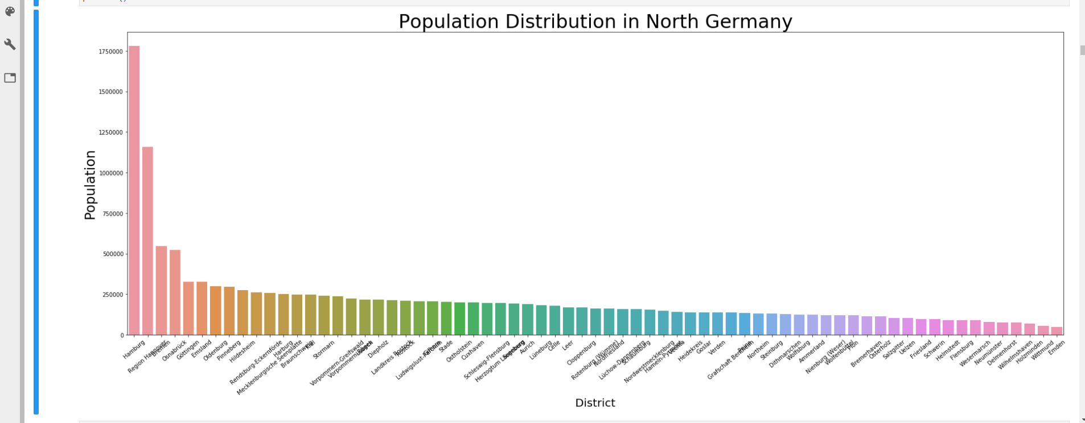Increasing Animal Adoption thru Pet Cafes in Northern Germany

**Figure 1: Distribution of Population for each district in North Germany**

Experiential Adoption:

Increasing Animal Adoption thru Pet Cafes in Northern Germany

A comparison of the population distribution for each State is made in order for us to get the top candidate locations for our selection.

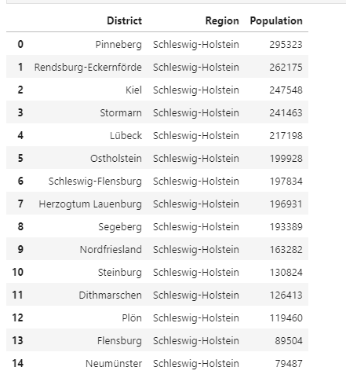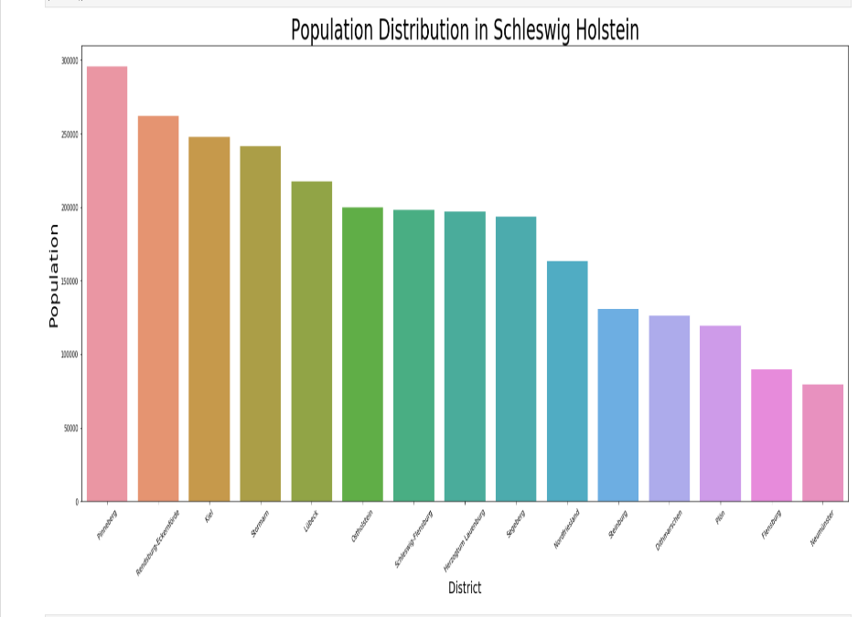**Fig.3&4: Data for Schleswig-Holstein**

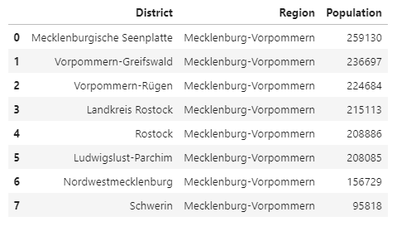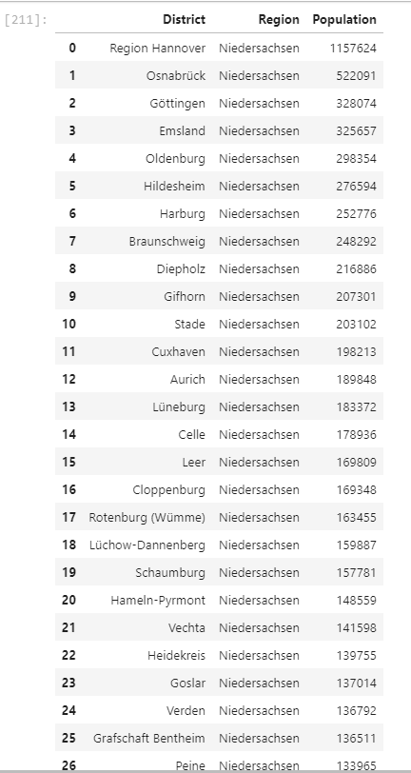F**ig.5: Data for Lower Saxony**

**Fig.6 Data for Mecklenburg-Pomerania**

Experiential Adoption:

Increasing Animal Adoption thru Pet Cafes in Northern Germany

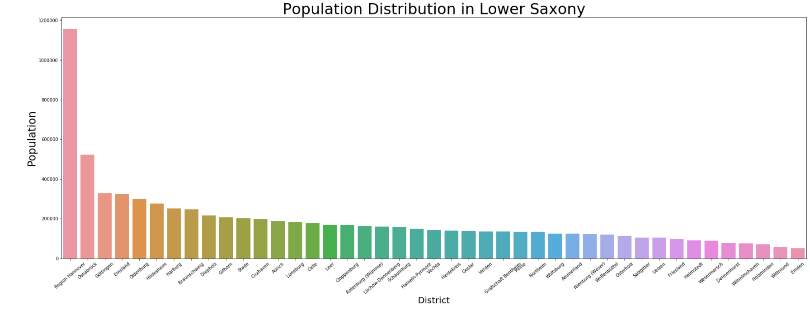

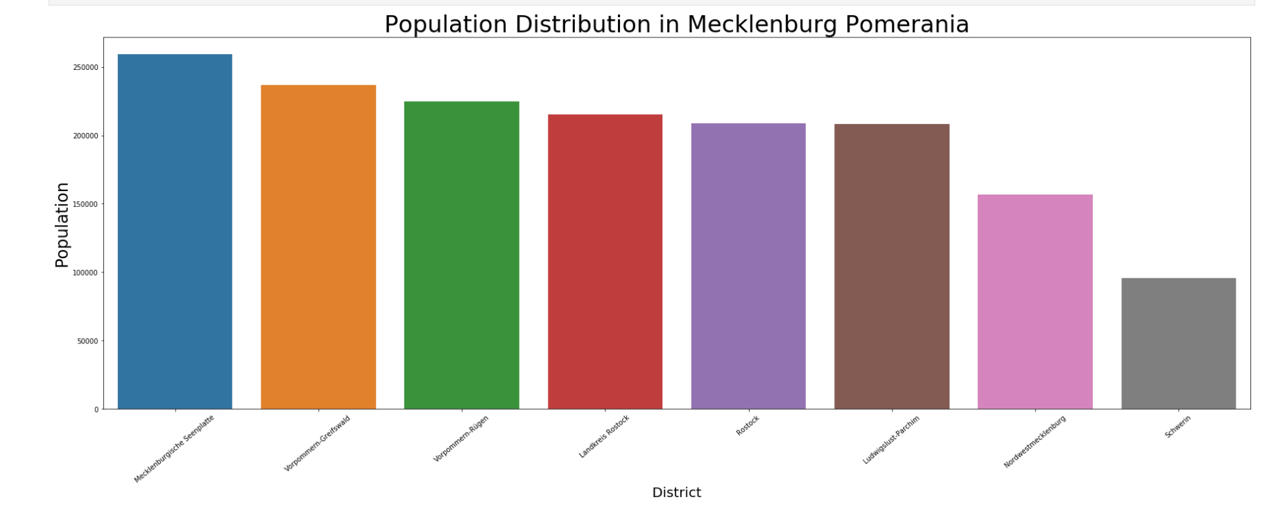

Experiential Adoption:

Increasing Animal Adoption thru Pet Cafes in Northern Germany

*3.2 Map Visualization*

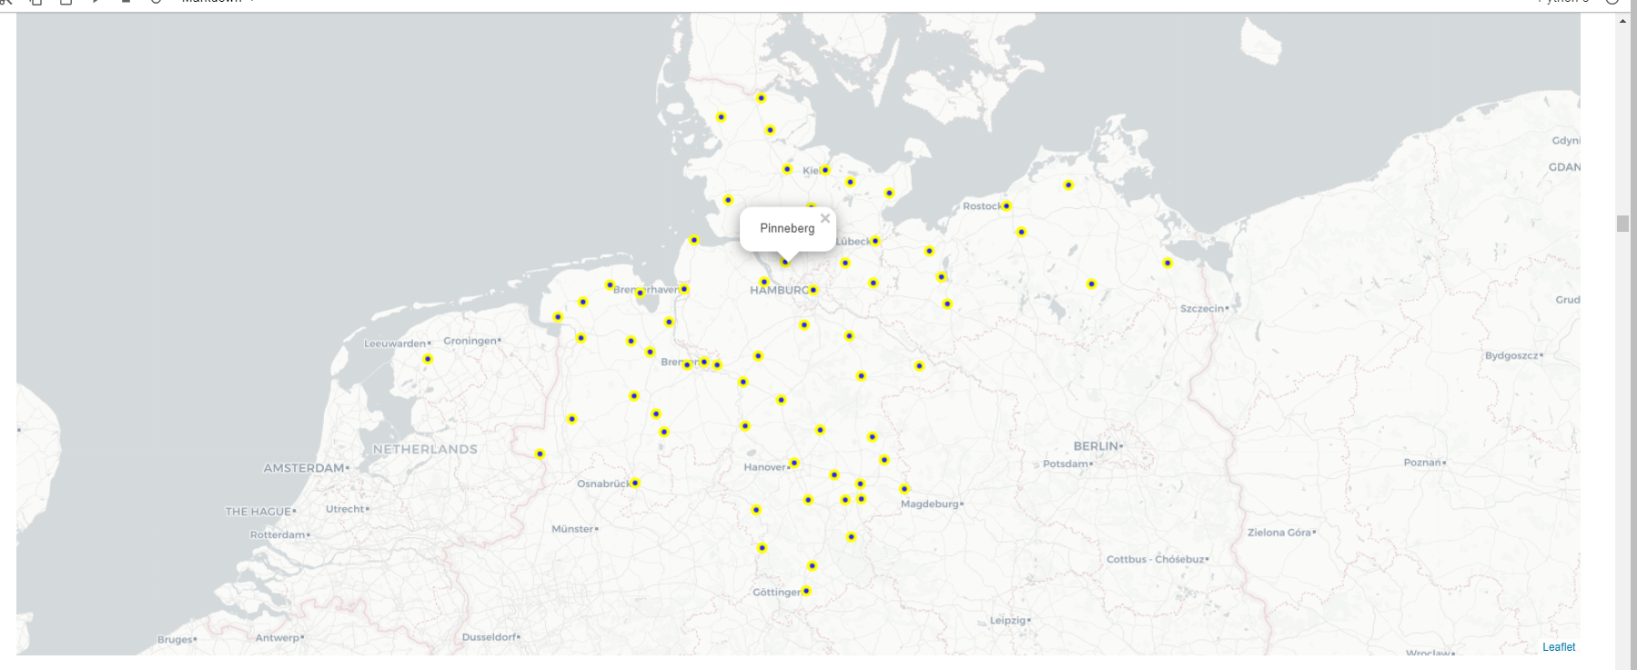Folium makes it easy to visualize data that’s been manipulated in Python on an interactive leaflet map. It enables both the binding of data to a map for choropleth visualizations as well as passing rich vector/raster/HTML visualizations as markers on the map. In this project, folium map is used to visualize the Districts of North Germany. The feature for a pop-up is also added so that when we hover and click on the label, the name of the District is displayed.

**Figure 9: Map showing districts in North Germany**

Experiential Adoption:

Increasing Animal Adoption thru Pet Cafes in Northern Germany

*3.3 Foursquare*

*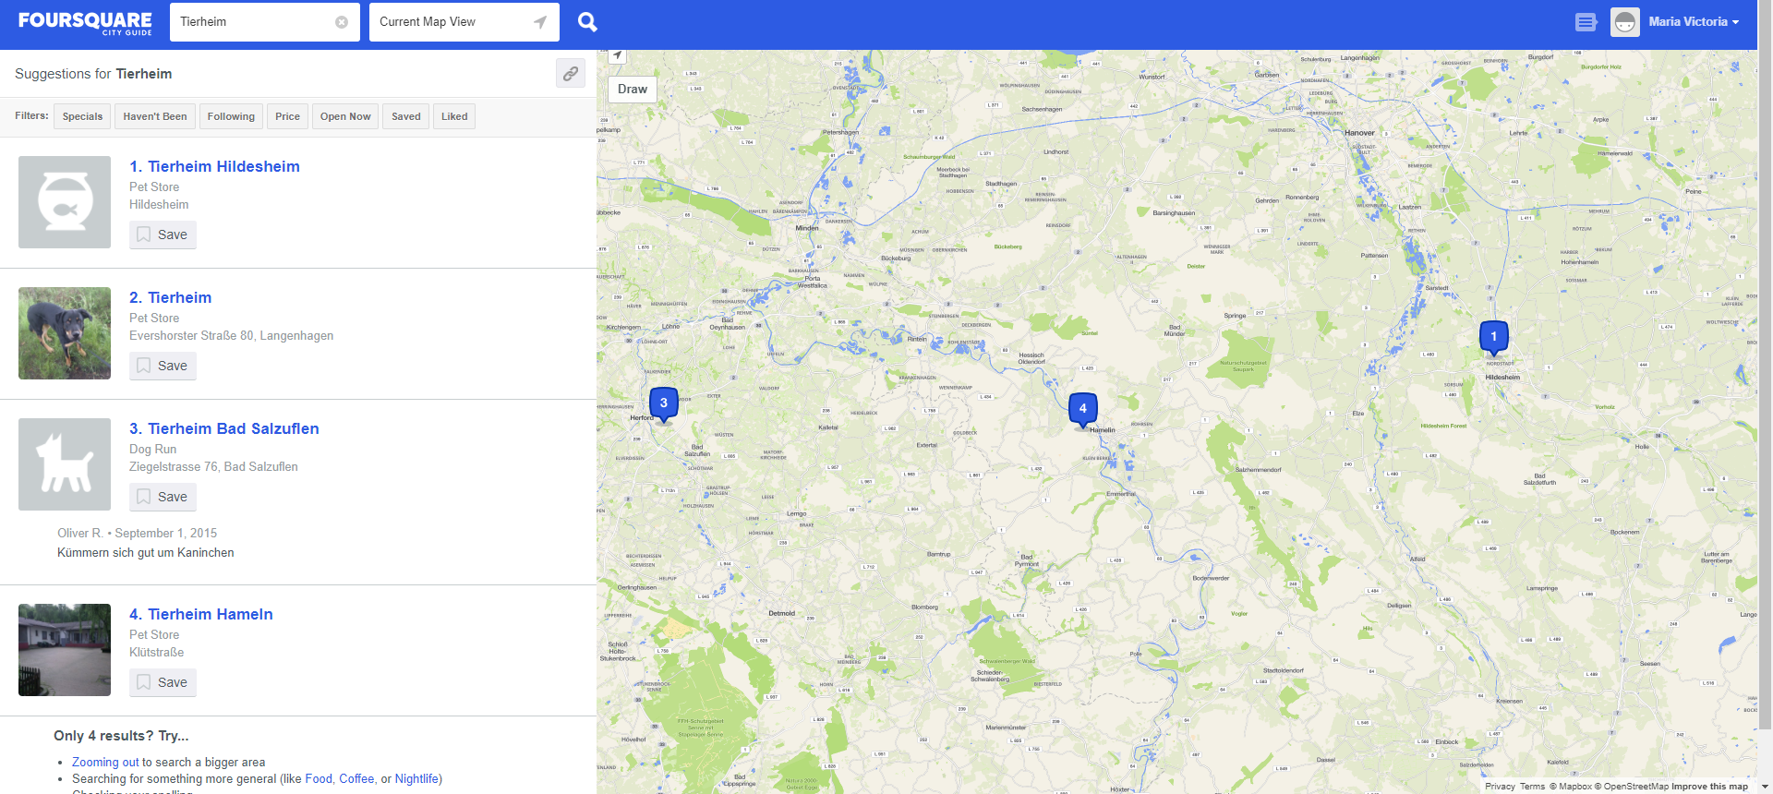***Foursquare City Guide**, commonly known as **Foursquare**, is a local search-and-discovery mobile app developed by Foursquare Labs Inc. The app provides personalized recommendations of places to go near a user's current location based on users' previous browsing history and check-in history.

As we are interested in specific type of venue such as Animal Shelter and Transportation services, we will have to use an API which can provide us with the data of the venues of interest in North Germany. Different types of calls can be made on Foursquare but as the numbers of calls per day are limited, I’ve set the ‘Limit’ to 100. There is another variable which is very important to raise a call with Foursquare, to get proper data: Radius. It decides the range in which the API will search for the Venues of interest and will provide the venues within that range. In this instance, after being able to acquire the list of Animal Shelters available in Foursquare, we would then extract an additional call to determine the transportation services nearby. We will not do this for all Animal Shelters but only for those that belong to the candidate districts.

Experiential Adoption:

Increasing Animal Adoption thru Pet Cafes in Northern Germany

3.4 Analysis of Foursquare Data

The Foursquare Places API provides location-based experiences with diverse information about venues, users, photos, and check-ins. The API supports real time access to places, Snap-to-Place that assigns users to specific locations, and Geo-tag. Additionally, Foursquare allows developers to build audience segments for analysis and measurement. JSON is the preferred response format.

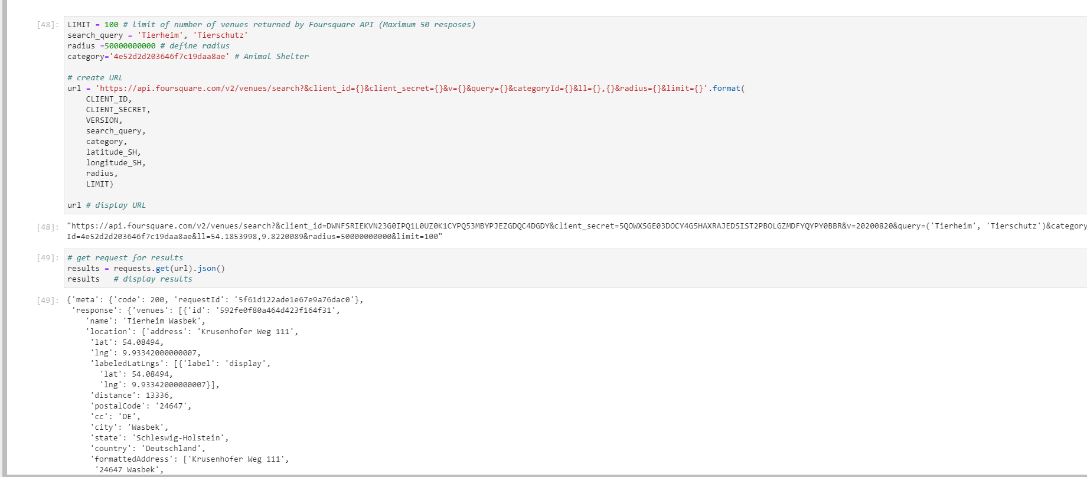Fig.11&12: Raw data from Foursquare API

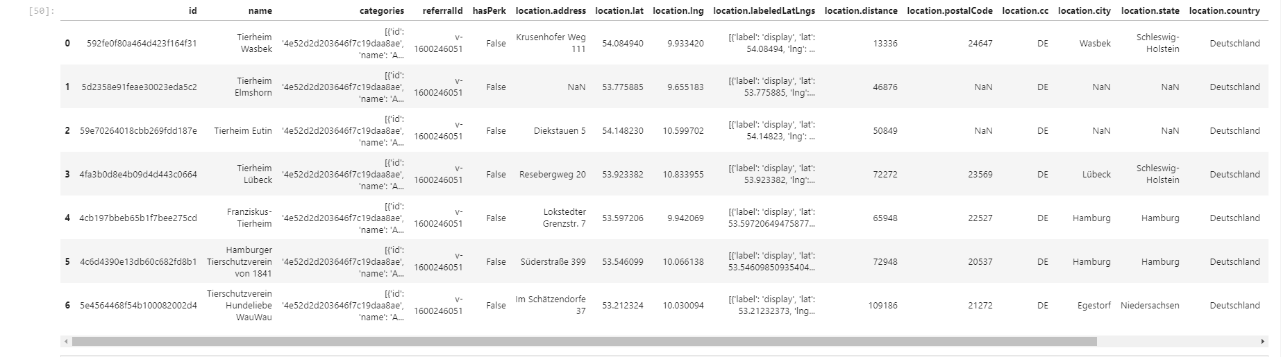The response format yielded is JSON, hence the data might not make sense if you try to decipher it without cleaning the data and importing it as a data frame. Once the data is cleaned, we get a better picture of the details included in the search

Experiential Adoption:

Increasing Animal Adoption thru Pet Cafes in Northern Germany

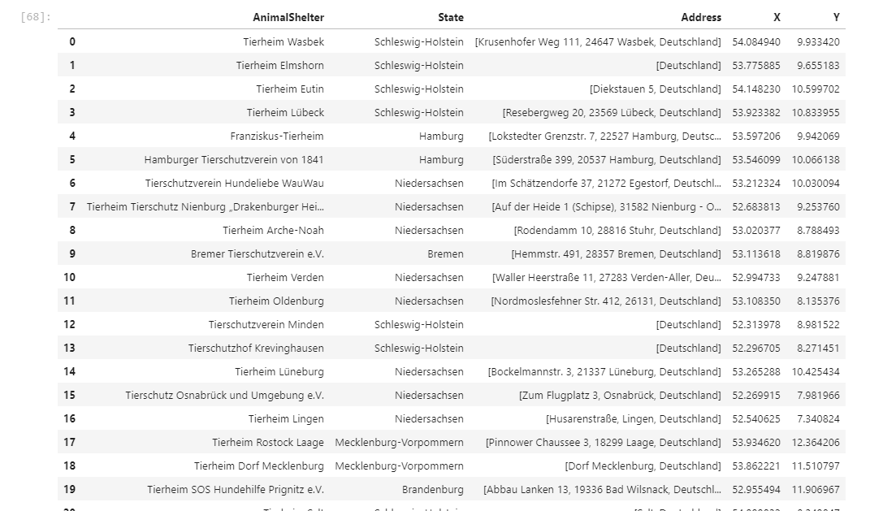We now managed to obtain a list of Animal Shelters in North Germany. In this data, the address, as well as the latitude and longitude were included. But this are not the only details that you can obtain thru Foursquare. There are other functions such as getting tips, rating and photos for selected venues.

Fig.13 List of Animal Shelters in North Germany

Experiential Adoption:

Increasing Animal Adoption thru Pet Cafes in Northern Germany

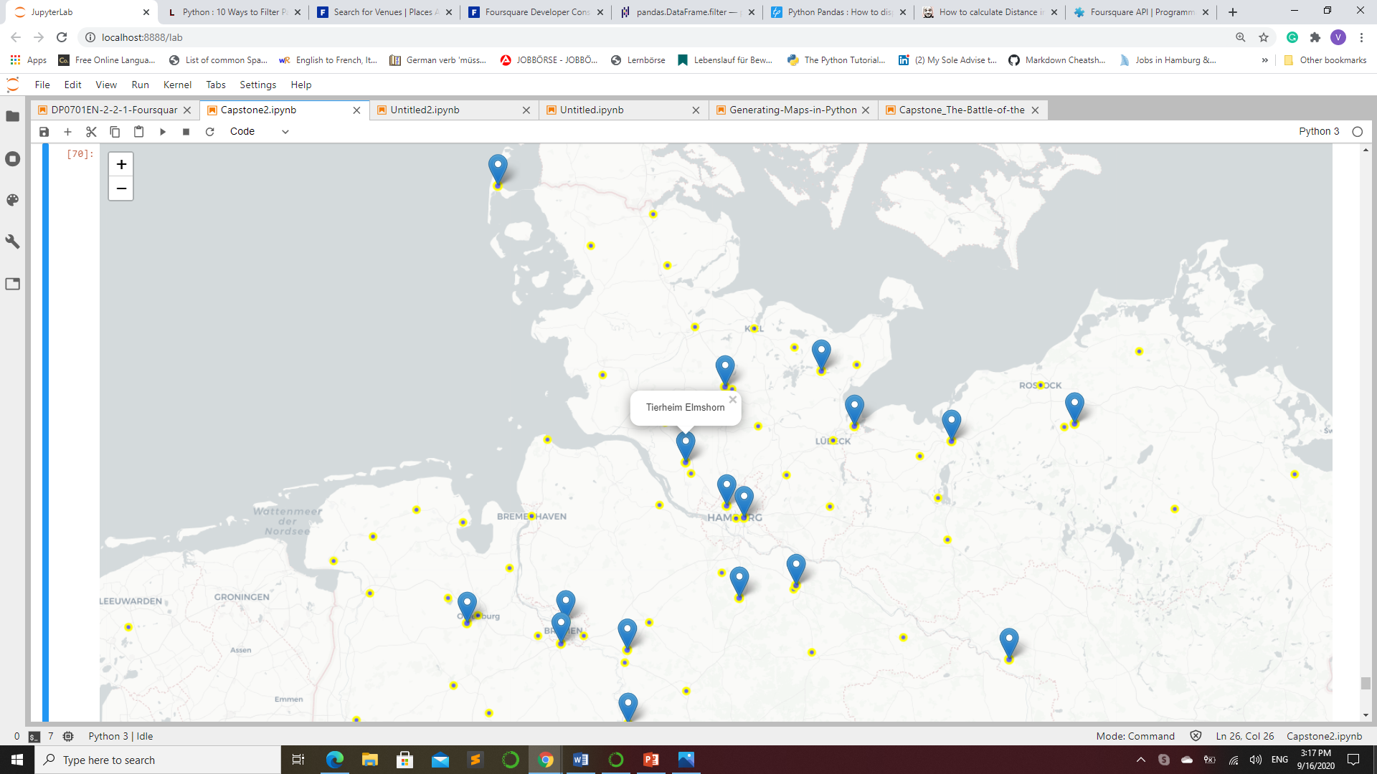

Using folium, we can visualize where the Animal shelters are situated. We can infer that despite the number of states and districts we considered, there are only a few animal shelters established in each state, hence the importance of selecting representative locations in order for us to establish Cafes equally in the targeted States.

Experiential Adoption:

Increasing Animal Adoption thru Pet Cafes in Northern Germany

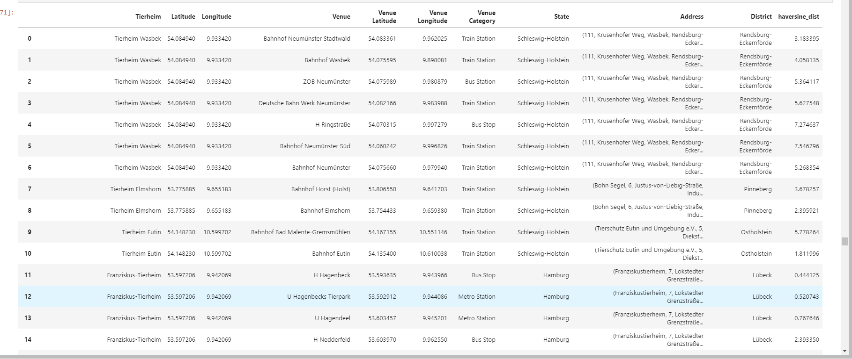 By further using Foursquare, we also managed to extract the location and number of transportations that are available within the range of the Animal Shelters.

Above we see a list of the transportation venues that where gathered thru Foursquare. The Venue are categorized as per what mode of transportation it is and the Address of each venue.

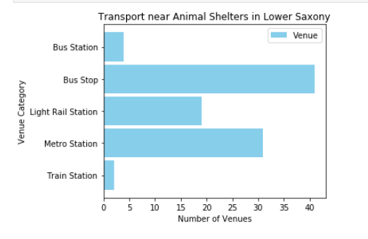

Here we see the number of transportation facilities available nearby the animal shelters in Lower Saxony (Niedersachsen).

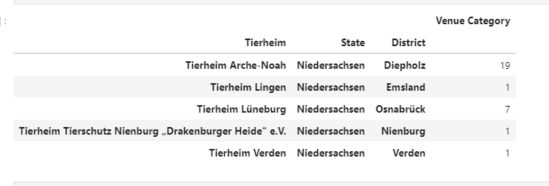

Transportation nearby Animal shelters in Mecklenburg-Vorpommern

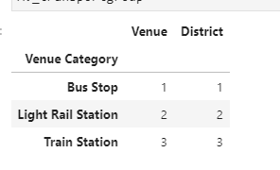

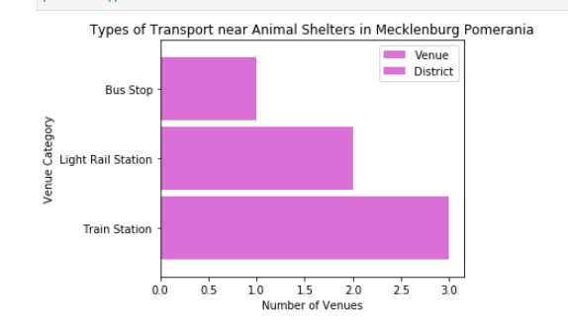

Transportation Services near Animal Shelters in Bremen

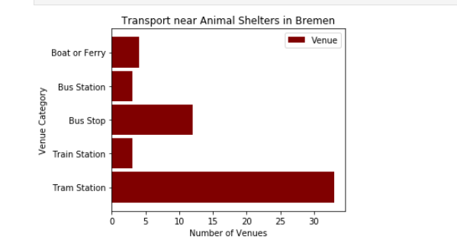

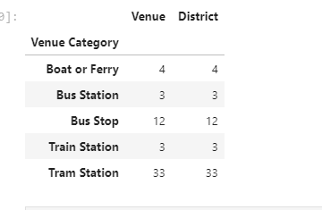

Transportation Services near Animal Shelters in Hamburg

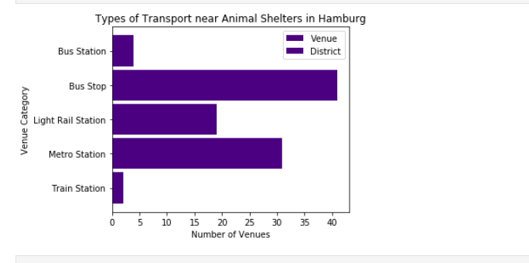

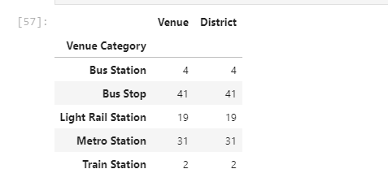

Transportation Services near Animal Shelters in Schleswig Holstein

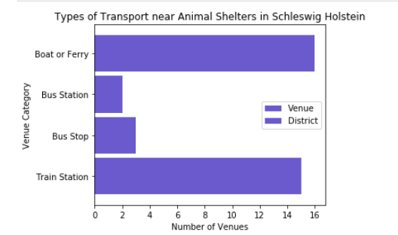

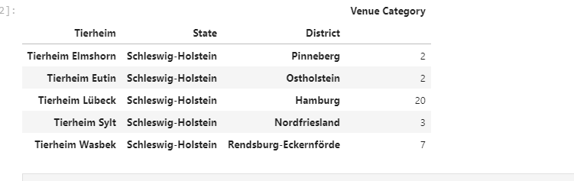

Experiential Adoption:

Increasing Animal Adoption thru Pet Cafes in Northern Germany

1. Analysis

Using Haversine Formula to calculate distance

This uses the ‘**haversine**’ formula to calculate the great-circle distance between two points – that is, the shortest distance over the earth’s surface – giving an ‘as-the-crow-flies’ distance between the points.

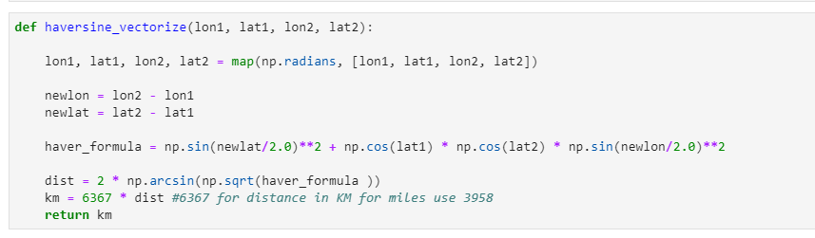The haversine formula[1](http://mathforum.org/library/drmath/view/51879.html) ‘remains particularly well-conditioned for numerical computa­tion even at small distances’ – unlike calcula­tions based on the *spherical law of cosines*. The ‘(re)versed sine’ is 1−cosθ, and the ‘half-versed-sine’ is (1−cosθ)/2 or sin²(θ/2) as used above. Once widely used by navigators, it was described by Roger Sinnott in *Sky & Telescope* magazine in 1984 (“Virtues of the Haversine”): Sinnott explained that the angular separa­tion between Mizar and Alcor in Ursa Major – 0°11′49.69″ – could be accurately calculated on a TRS-80 using the haversine.

**K-means clustering**

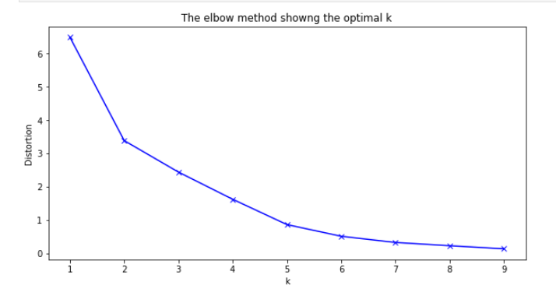In cluster analysis, the '*elbow method*' is a heuristic used in determining the number of clusters in a data set. The method consists of plotting the explained variation as a function of the number of clusters and picking the elbow of the curve as the number of clusters to use. The same method can be used to choose the number of parameters in other data-driven models, such as the number of principal components to describe a data set.

Experiential Adoption:

Increasing Animal Adoption thru Pet Cafes in Northern Germany

Using K-means clustering, we get a list of the Most Common Venues for each of District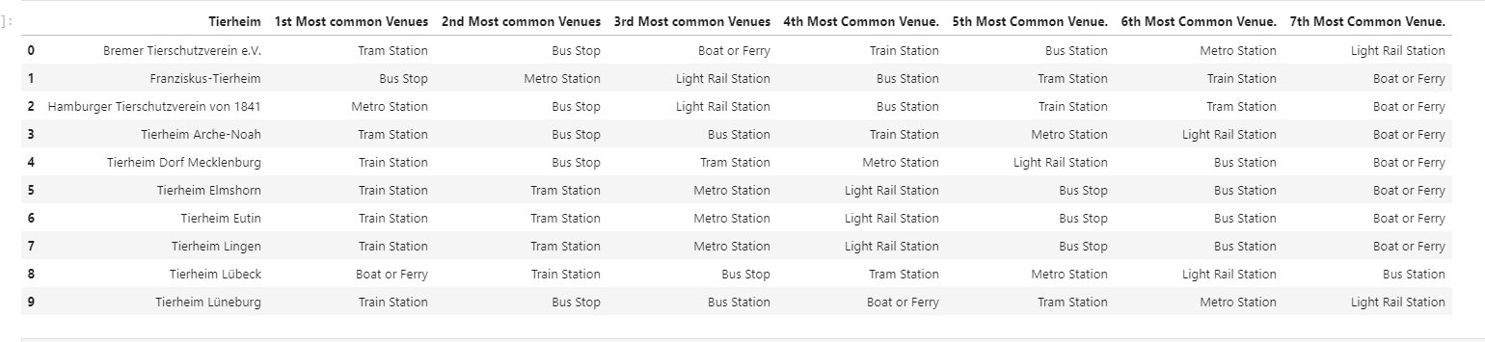

Having the data above, we can use folium to visualize the distribution of transportation services for each District. The clustering will also enable us to see similarities for each designated cluster.

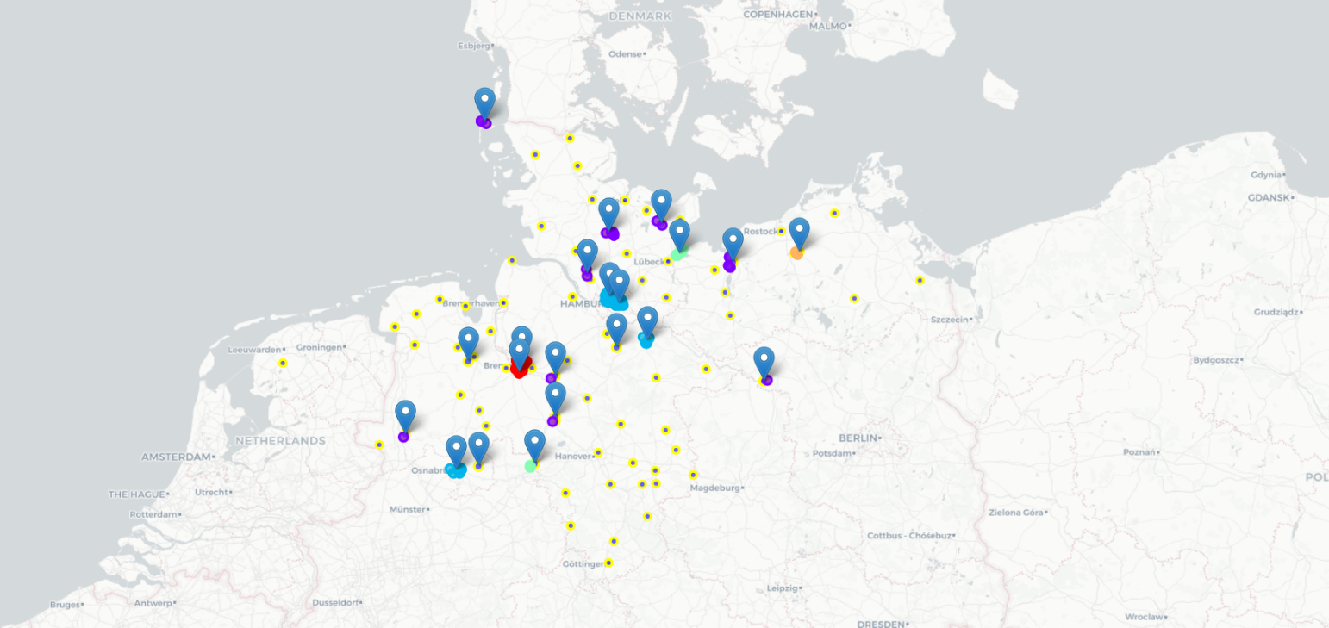

Experiential Adoption:

Increasing Animal Adoption thru Pet Cafes in Northern Germany

***Exploring the Clusters***

**Cluster 0**

1. Comprised of 7 Districts, Emsland, Osnabrück, Verden, Bremen, Diepholz, Lüneberg and Nienburg

2. Foursquare returned 4 similar transportation categories for each district namely: Train Station, Bus Stop, Boat or Ferry,and Tram Station.

3. Out of all these categories, the cluster's main similarities is derived from the list of " Most common venues". As you may notice, the districts above have the same top 3 rankings for the "most common venues"

**Cluster 1**

1. Comprised of 5 Districts: Nordfriesland, Minden-Lübecke, Lübeck, Ostholstein, Pinneberg, and Rendsburg-Eckernförde.

2. Foursquare returned 4 similar transportation categories for each district namely: Train Station, Bus Stop, Boat or Ferry, Bus Station.

3. Out of all these categories, the cluster's main similarities is derived from the list of " Most common venues". As you may notice, the districts above have the same top 3 rankings for the "most common venues"

**Cluster 2**

1. Comprised of only 1 District: Brandenburg

2. Foursquare Train Station for the unique category for this district

**Cluster 3**

1. Comprised of only one District:Hamburg.

2. Foursquare returned 5 similar transportation categories for each district namely: Train Station, Bus Stop, Metro Station, Bus Station, Light rail station.

3. Out of all these categories, the cluster's main similarities is derived from the list of " Most common venues". As you may notice, the districts above have the same top 3 rankings for the "most common venues"

**Cluster 4**

1. Comprised of only one District: Mecklenburg-Vorpommern.

2. Foursquare returned 3 similar transportation categories for each district namely: Train Station, Bus Stop, Light rail station.

3. Out of all these categories, the cluster's main similarities is derived from the list of " Most common venues". As you may notice, the districts above have the same top 3 rankings for the "most common venues"

1. Results and Discussion

Our analysis shows that although our selected land Area is big, the number of Animal Shelters yielded were only a few. The venues for these shelters are also not close to the city centers, most of them are in remote villages-most likely to be able to accommodate space and not to disturb residential areas. Being in remote areas will also help their animals to be more at rest.

Although there are a lot of transportation facilities available around the Animal Shelters, most of them are situated approximately around 1 km away from the Shelter. At most, one bus stop is ~300 meters from the Animal Shelter in Hamburg. Most of the Shelters are more accessible thru use of private vehicles. Train Stations are even further with approximates ~5km distance from each Shelter.

Interestingly, some Shelters can be accessed by Boat and Ferry. Most of which are located near the coast.

Recommended zones should therefore be considered only as a starting point for more detailed analysis which could eventually result in location which has not only no nearby competition, but also other factors taken into account and all other relevant conditions met.

It is also noteworthy that as compared with Foursquare, Google maps had yielded more results for Animal Shelters using the ‘Search Nearby’ option. This might be attributed to the fact that Foursquare is not popularly used in Germany.

1. **Conclusion**

The purpose of this project was to identify areas in North Germany with Animal Shelters close to transportation services and with a good population distribution in order to aid stakeholders in narrowing down the search for optimal location for a new Pet Cafe. By acquiring Animal Shelter venues from Foursquare and the Population data from each District, we have identified the top Districts that justify further analysis

We then generated extensive collection of transportation locations which satisfy some basic requirements regarding nearby transportation services. Clustering of those locations was then performed in order to create areas of interest and addresses were created to be used as starting points for final exploration by stakeholders.